Access Pass Holder Handbook
Updated July 1, 2020

Sailing is real. It is authentic. It’s not always great, but it is better than not being there, and it sometime inspires. And it hammers most sailors into resilient and contented folks with true stories of surprise, humility, resourcefulness, and grit, because they are among the last few humans to actually be in nature.
And it begins, ironically, in the shadow of a busy city, a short drive or walk from the office or school. An urban outdoors; ancient, unvarnished, organic and wild, one step off a dock and just outside of a seawall. Sailing’s best-kept secret.
-Nick Hayes, author of Saving Sailing

Welcome to Community Sailing New Orleans Inc.

We at CSNOI think that sailing is something worth sharing. It brings you to a place that is ever more difficult to reach in this busy world. Sailors appreciate teamwork, the importance of communication, and take pride in their craft….
As an access pass holder, your dues help fund our youth development and adaptive sailing programs for the greater New Orleans area.

Each month, we will update you with upcoming events here at CSNOI. Included will be highlights of our outreach programs as a reminder of how you are helping us do good work for the community. The following pages will serve as your access pass holder handbook, helping you navigate the waters. Thank you for being part of your community sailing center, and we look forward to seeing you out on the water soon!

Fair Winds,
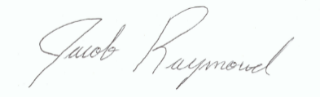
Jacob Raymond, Executive Director

Our Mission
To positively impact lives by providing accessible educational and recreational opportunities on Lake Pontchartrain for people of all ages, backgrounds, and abilities.

Access Pass Holders
As an access pass holder, your dues help fund our youth and adaptive programs.
Passes are valid for one year from the date you enroll, it is limited to individuals 18 years of age or older, and grants you access to:
- Paddle boards
- Club 420s
- Independence 20s
- Capri 26
- Socials
- Racing
- Discounts on classes, courses and youth camps
- Newsletter

Access Pass Holder

Student Pass: $250
- Ages 18-26
- Enrolled full time in school
- Access to Paddle Boards, Club 420s, and Independence 20s
- No guest fees
- 10% off adult sailing classes

Individual Pass: $350
- Access to the Paddle Boards, Club 420s, and Independence 20s
- $10 guest fee
- 10% off of youth summer camps
- 10% off adult sailing classes

Family Pass: $500
- Access to Paddle Boards, Club 420s, Independence 20s, Capri 26
- No guest fees
- 10% off of youth summer camps
- 10% off adult sailing classes
Corporate Pass: $2,000
- 5 Family passes with all benefits
- 10 % off of team building events

How Do I Qualify to Be A Skipper?
- Written Test
  - 25 questions, multiple choice
  - 75% or better to pass
- Practical Test
  - Please request outline
  - Paddle boards require no test, but pass holders must complete a water safety briefing with CSNOI staff before taking out a board

How Can I Go Sailing?
A few simple ground rules:
- Life vests/ PFD’s will always be worn while sailing or paddling
- Always give way to tugs, barges, ships, ferries, and all other commercial traffic
- Must monitor VHF Channel 71 and 16 at all times
- Pass holders must adhere to all directives of CSNOI staff while using the vessels
- Sail with consideration for the safety of your crew, yourself, other boaters, and the equipment.

- Minimum number of people to leave the dock:
  - One Skipper member
  - One crew 12 years or older
- Maximum people onboard
  - 1 per paddle board
  - 2 per Club 420
  - 5 per Independence 20
  - 8 per Capri 26
How to Make A Reservation
- Visit our website at nolacommunitysailing.org
- Log in
- Go to reservation calendar
- Click add new event
- Use your name as the event title
- Select date and time
- Scroll down and click save and continue
- You can edit the reservation on the calendar
- Not tech savvy? Then just give us a call at 504.233.3292 to make a reservation
Reservation Policies
1. CSNOI’s cornerstone programs of youth development and adaptive sailing takes priority over access pass holder’s sailing. CSNOI has the right to decline or cancel a reservation if it interferes with such.
2. CSNOI employees have the ultimate authority to cancel reservations if they have any concerns of weather conditions that could harm any CSNOI participants.
3. No single-handing. Access Pass Holders must have a guest over the age of 12 who can act as your crew member.
4. Boats may be reserved for up to 2-hours per day. Please contact the office for special permission to reserve boats for past those limits.
5. Please abide by our normal operating hours and procedures, including making your reservation two hours in advance. CSNOI Staff have the right to alter or delete a reservation that falls outside of the below hours:
- Wednesday – Friday 12 pm – half an hour before official sunset.
- Saturday: 10am- Half an hour before official sunset (12pm- Half an hour before official sunset in winter).
- Sunday: 12pm- Half an hour before official sunset.
- Closed for sailing from January 1st until March 1st of 2021.
- *Same-day reservations must be made no later than 4pm. Reservations made after 4pm do not guarantee the sailing center will be open. Ex: if you want to sail at 6:30pm on a Saturday, please make your reservation by 4:00pm the same day.
5. If you need to change or cancel your reservation, you may do so on the reservation calendar. Skippers can select the reservation they created, and use the event set-up to adjust date and time. To cancel your reservation, please make it "private." This will remove it from the calendar. You may also call 504.233.3292 to cancel.
*Please note, the same hours and procedures as outlined above apply to changing dates and times. Time changes for same-day reservations must be done no later than 4pm that day. If you need to cancel your reservation, please do so with as much notice as possible.
6. Use your name as the event title. This lets us know who is coming out in case we need to contact you for any reason.

Rules

Sailing is not allowed in winds over 20 mph. During the winter, this limit is lowered to sustained 15mph or gusts of 20mph. CSNOI reserves the right to cancel sailing at any time if wave height is questionable.

If lightening is seen or thunder heard, no boats will be permitted to sail until 30 minutes has passed and there is no present threat.

No boats should be taken to any other docks unless of an emergency or CSNOI instructor is aboard.

Skippers must use the boat log and include all persons on board and record a float plan of time to be expected on the water.

Boats will remain in the designated sailing area described CSNOI. Staff members may restrict sailing areas at their discretion and Skippers must adhere to these limits.

Personal Floatation Devices (PFD’s) must be worn and properly secured while on the boats at all times.

Alcohol and smoking are not allowed on CSNOI boats. Use of alcohol before or onboard the boats will result in suspension of sailing privileges.

CSNOI boats may not be used for any fee-for-service based activity unless it is conducted by CSNOI staff.

Skippers must report ALL accidents, injuries, and collisions to a manager. Failure to report any incidents may result in suspension of privileges. Staff must complete an Incident Report for documentation purposes. If you are involved in ANY type of collision with a boat, seafloor, wall or other obstruction, you must report it to manager on duty – no matter how insignificant you believe it was.

CSNOI Skippers are responsible for their guest’s behavior and safety. Unruly, boisterous, and/or dangerous behavior may result in the suspension of the members’ sailing privileges. Respect all safety rules and the rules of the road.

CSNOI Skippers are responsible for evaluating the weather conditions and exercising discretion.

No boat can leave the dock without a radio onboard. A radio check must be performed before leaving the dock, and will serve to inform the center what boat you are taking. The radio must be on, turned to an audible volume for the conditions, and scanning channels 16 and 71. CSNOI Skippers must provide their own handheld VHF radio. If necessary, a radio can be borrowed.

Swimming is not allowed.

Do not go on the foredeck unless the boat is tied up at the dock and the jib is furled.

Unless there is an evening sailing event, all CSNOI boats must be at the dock 30 minutes before sunset.

Single handing sailing is not allowed. Boats must have a certified CSNOI certified Skipper and at least one crew 12 years of age or older. CSNOI reserves the right to restrict, or not allow, Skippers to check out boats based upon their crew and other factors.

Damage to the boats will be reviewed by CSNOI staff to determine if negligence was a factor. Skippers are responsible for negligent damage up to $(deductible).

Pets are not allowed on CSNOI boats.

Sailing Area
At any time, CSNOI staff has the right to restrict the following outlined sailing area. Special permission may be given by the Executive Director to sail past these boundaries for group or special events. Sailboats will not go further West then yellow marker S, nor North of yellow markers C and T, or beyond yellow marker H to the east. Paddle boards may not go beyond 50 yards off the shoreline.
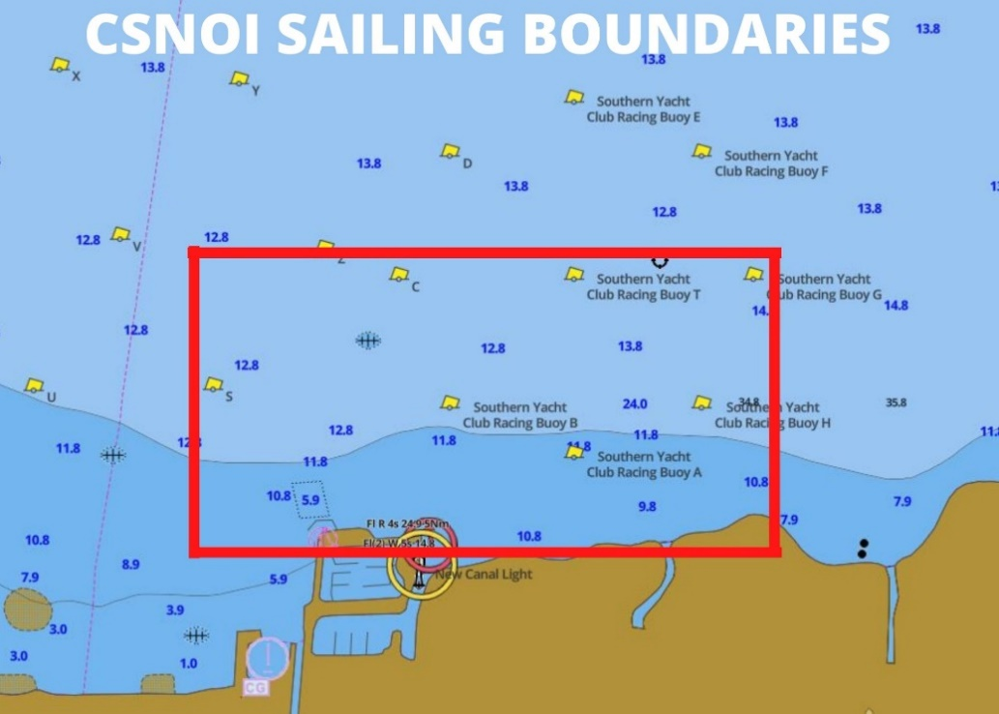

Emergency Procedures and Guidelines
- Monitor the weather. If conditions look questionable don’t wait for CSNOI staff to hail you. Head back immediately and alert all CSNOI boats if you see lightning, hear thunder, or have other concerns. Sail by the motto “rather be at the dock wishing you were on the water rather on the water wishing to be back on dock.”
- Try to anticipate situations before they become emergencies. Many situations can often be prevented. Get the boat under control, prevent any additional injuries or boat damage, and try to reduce further risks.
- Be pro-active. Doing nothing often results in the deterioration of conditions. Make and execute your decisions with the safety of the crew and the boat in mind.
- Get the attention of CSNOI staff. If needed, hail a nearby boat and have them radio the Sailing Center by using their VHF marine radio or cell phone.
- Assess the situation and try to resolve any equipment problems. You may be able to sail back to the dock depending on the condition of the boat or type of equipment failure.
- For minor sailing injuries, use the safety kit located on each boat. Again, you may be able to sail back to the dock and get medical attention depending on the condition of the injured. However, in the event of an emergency, hail assistance immediately following the emergency action plan included in the safety box.
- All CSNOI pass holders are required to notify CSNOI staff in the event of any sailing accident, injury or equipment failure. Staff must document all accidents and injuries.
- It’s every Skipper’s responsibility to evaluate their own comfort level with the weather conditions and the crew’s skill set to safely operate the vessel.
- Be considerate when taking out new sailors and operate in mild conditions.

Emergency Action Plan in Inclement Weather
- Anyone who sights signs of adverse weather is responsible to alert all CSNOI staff on VHF Channel 71 and will repeat the message until they receive confirmation of transmission.
- Manger on Duty will order all boats back to CSNOI docks.
- All available trained staff will be sent out to in safety boats to escort people in.
- Manager on Duty will begin a role call on VHF 71 to confirm the position of each boat.
- Boats will begin to motor if winds exceed 20 mph.
- If time does not permit to return CSNOI docks and the north end of the entrance docks is available, have boats tie up there.
- Once boats are at the dock, no one should attempt to de-rig them.
- If a boat cannot make it back to the docks, have the vessel anchor, record location, rescue the sailors via coach boat and only retrieve when the weather has cleared.
- The Manger on Duty will conduct a head count of all sailors when ashore.
- Manager on Duty will account for and retrieve any equipment afterwards.

Become a Pelican: Volunteer Opportunities
- Mentor: Show a fellow access pass holder how to use the equipment and show them the ropes of CSNOI. Pass on your experience and expertise in one-on-one sailing sessions. Your own schedule
- Instructor: We’ll help train and help reduce fees to become a certified US Sailing Level 1 Instructor if you volunteer to help teach our youth development or adaptive sailing courses.
- Maintenance: We could always use a hand fixing or cleaning a boat.
- Hurricane Prep Team: Have a truck to tow boats, a strong back to shuffle around some equipment, or just an extra pair of hands to help tie down a boat? Please let us know if you’d be interested in helping us prepping for storms to safeguard the community’s boats.

